**PRACTICAL 8**

**AIM:** To create the following topology:

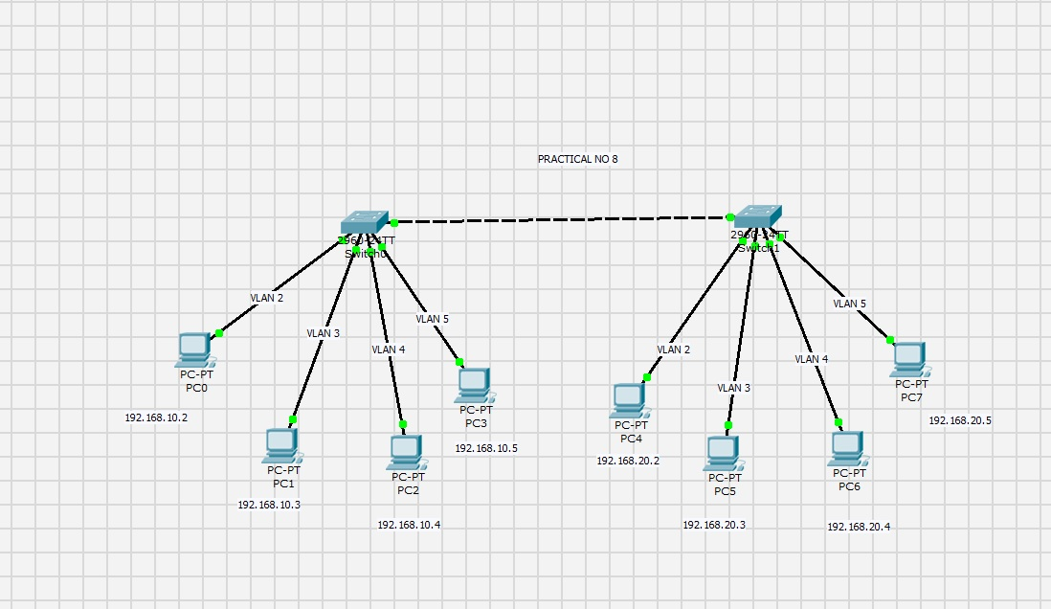

**PC0:**

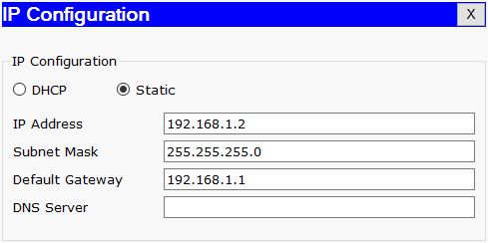

**PC1:**

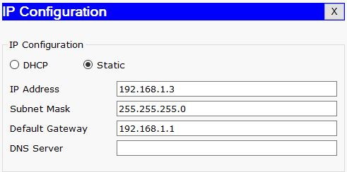

**PC2:**

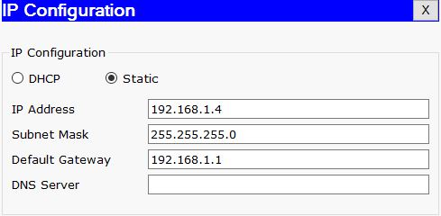

**PC3:**

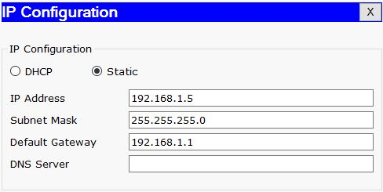

**PC4:**

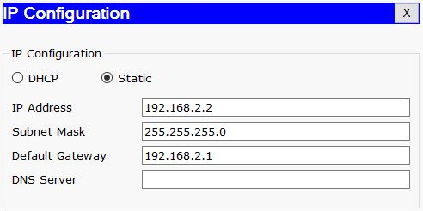

**PC5:**

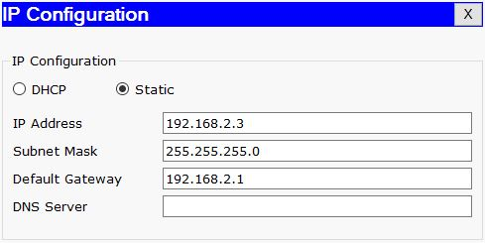

**PC6:**

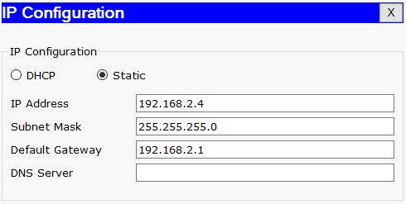

**PC7:**

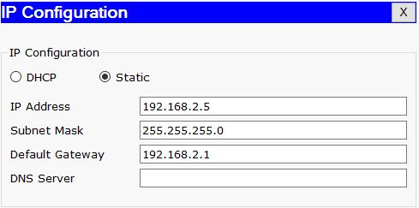

**Switch0 and Switch1:**

Switch>en

Switch#config t

Enter configuration commands, one per line. End with CNTL/Z.

Switch(config)#int fa0/1

Switch(config-if)#switchport mode access

Switch(config-if)#switchport access VLAN 2

% Access VLAN does not exist. Creating vlan 2

Switch(config-if)#int fa0/2

Switch(config-if)#switchport mode access

Switch(config-if)#switchport access VLAN 3

% Access VLAN does not exist. Creating vlan 3

Switch(config-if)#int fa0/3

Switch(config-if)#switchport mode access

Switch(config-if)#switchport access VLAN 4

% Access VLAN does not exist. Creating vlan 4

Switch(config-if)#int fa0/4

Switch(config-if)#switchport mode access

Switch(config-if)#switchport access VLAN 5

% Access VLAN does not exist. Creating vlan 5

**Output:**

